1] I have created database in Xampp, So first create database named food and then create table users inside food database

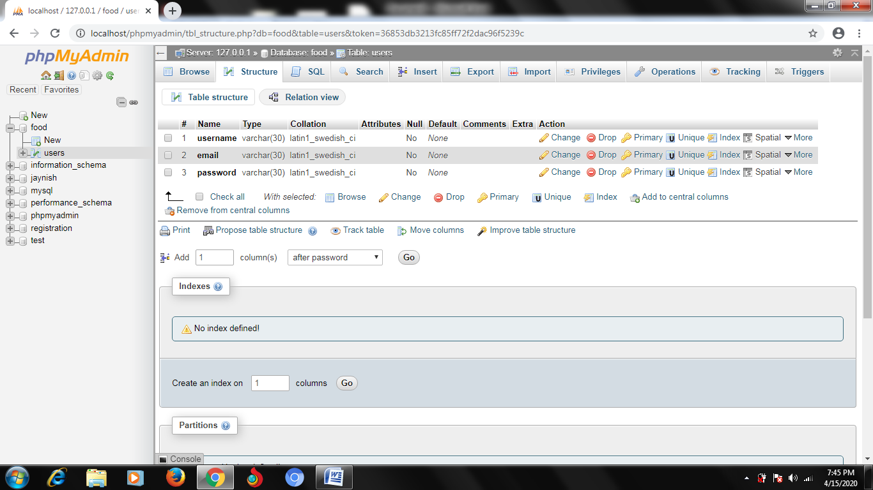

2] And the Save all the files in htdocs and run file name home.php in web browser using localhosts.

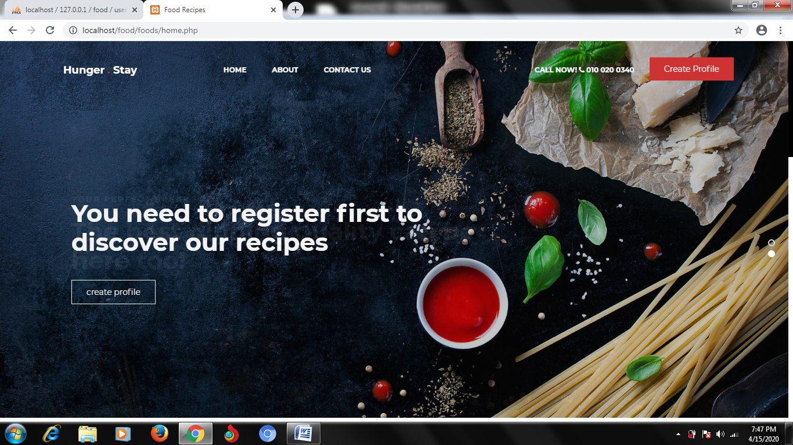

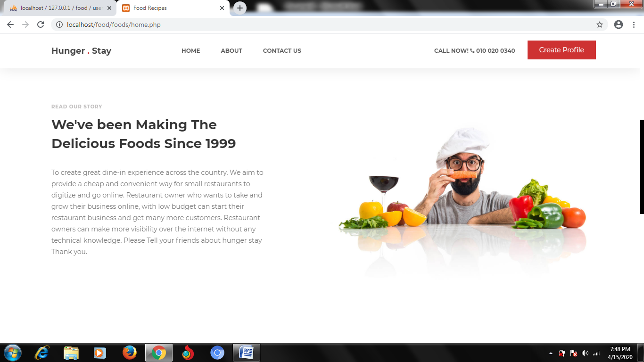

3] You need to register yourself first before signing in

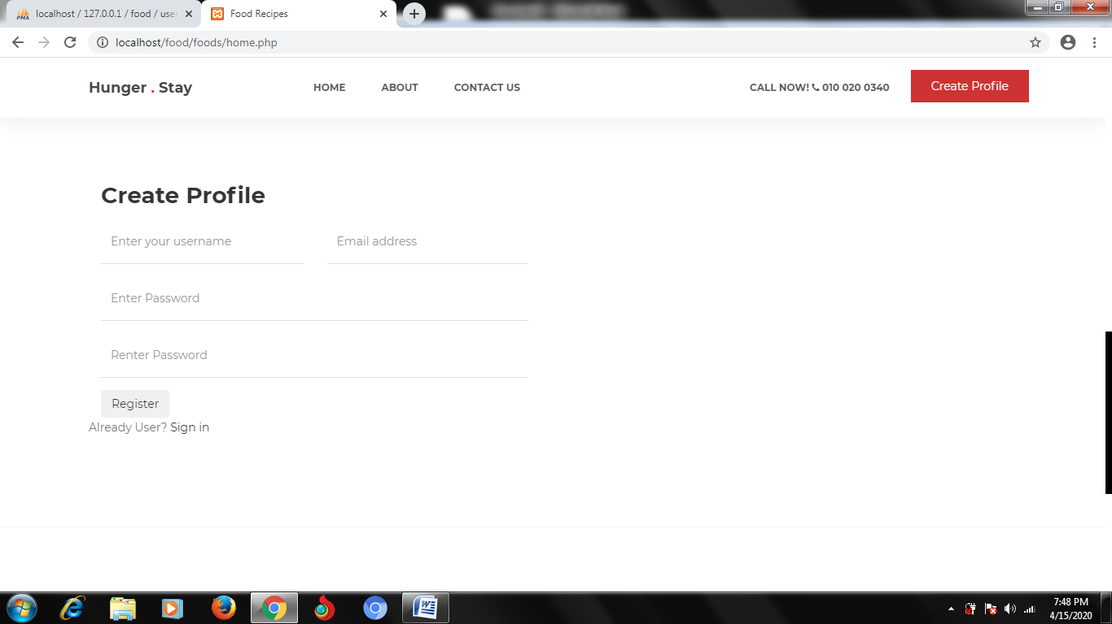

4] After registering you can sign in and it will take you to loggedin page.

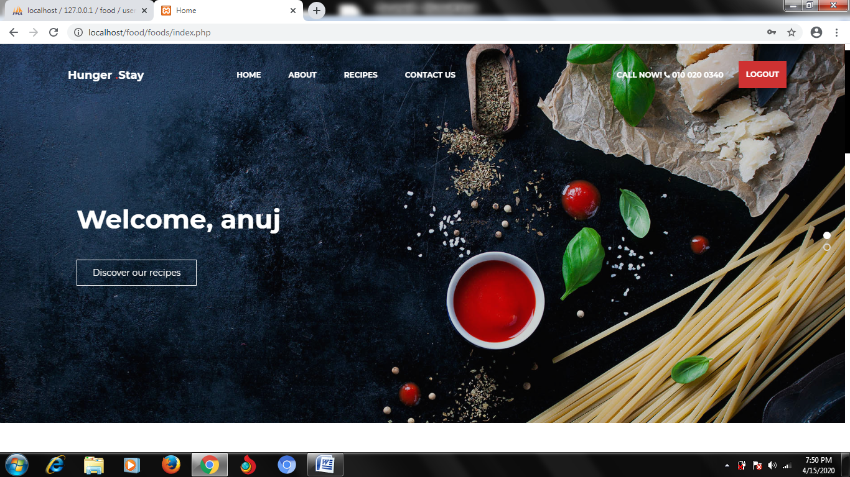

5] You can view and search recipe once you are logged in

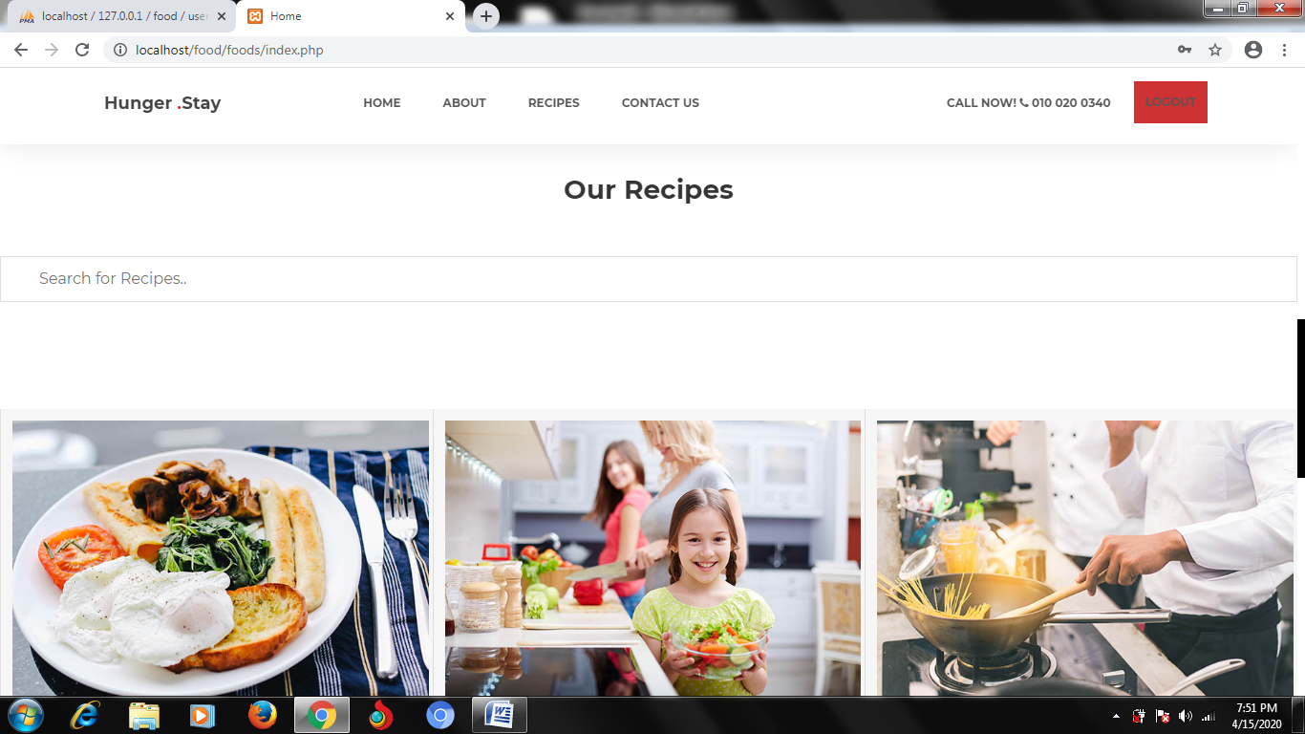

Languages that have been used are

* HTML
* CSS
* JAVASCRIPT
* BOOTSRAP
* PHP
* MYSQL
* JQUERY